Space Ship Example

The following example demonstrates how to use RapidIoC to create an actual game. It is based off of Unity’s Space Ship Tutorial. I recommend to check out GettingStartedExample and SceneManagementExample first.

# How to run this example

1. Open **BuildSettings** (File->BuildSettings).
2. Add the following scenes to **Scenes in Build**:
   * RapidIoC/examples/SpaceShipExample/mainScene/MainScene.scene
   * RapidIoC/examples/SpaceShipExample/menuScene/MenuScene.scene
   * RapidIoC/examples/SpaceShipExample/gameScene/GameScene.scene
   * RapidIoC/examples/SpaceShipExample/GameOverScene/GameOverScene.scene
3. Your build settings should look something like this:

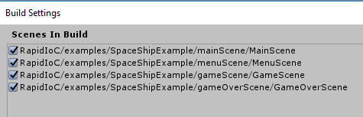

1. Load **MainScene** (RapidIoC/examples/SpaceShipExample/mainScene/MainScene.scene)
2. Run the game.

